Whole School Pupil Survey 2017
We asked the pupils about the things in school that they liked and disliked
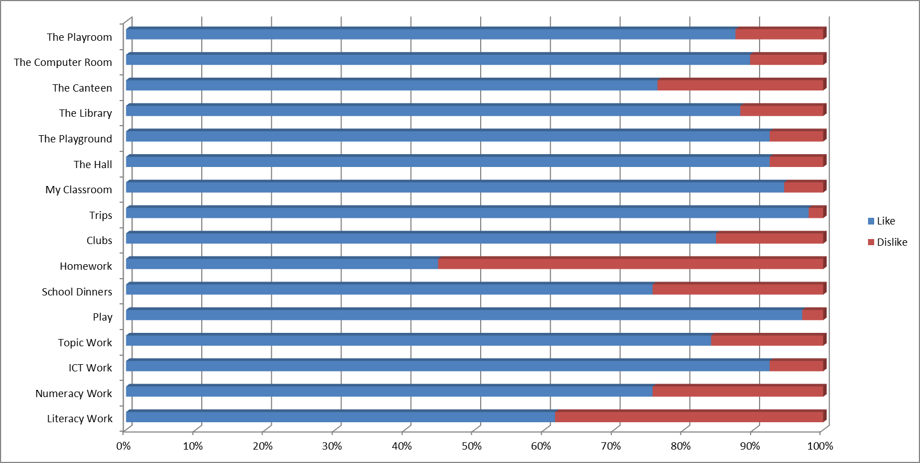

We then asked the pupils to answer True or False about the following statements
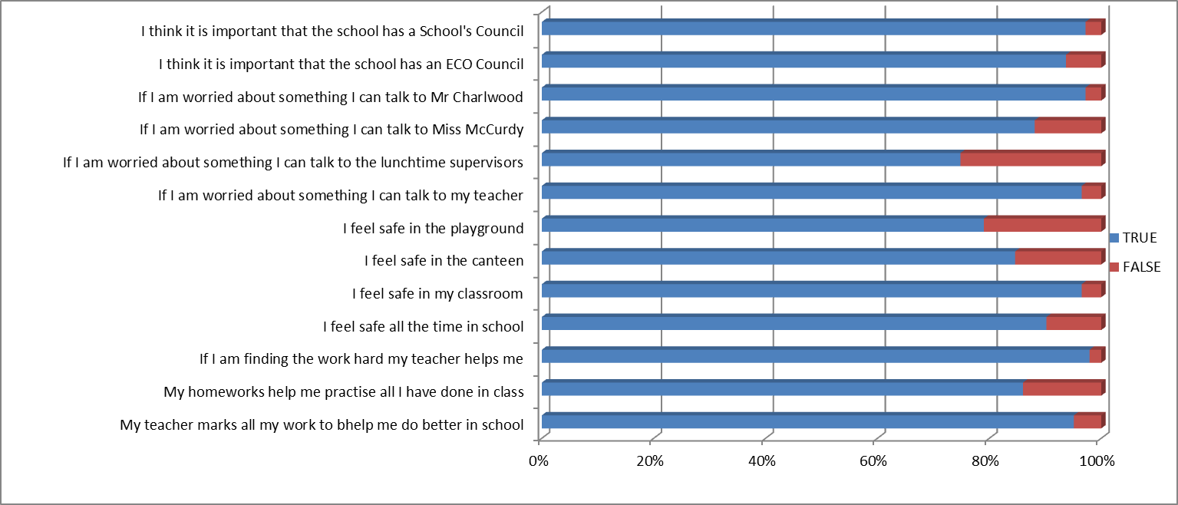

We asked the pupils about what they thought about the difficulty of the work they were given
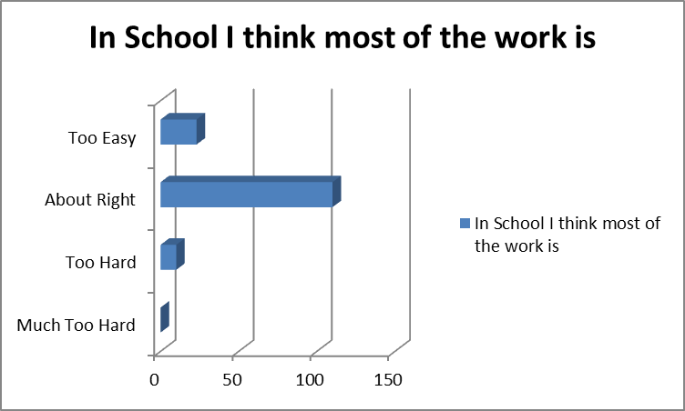

We then asked the pupils to list all the things that they liked about the school…
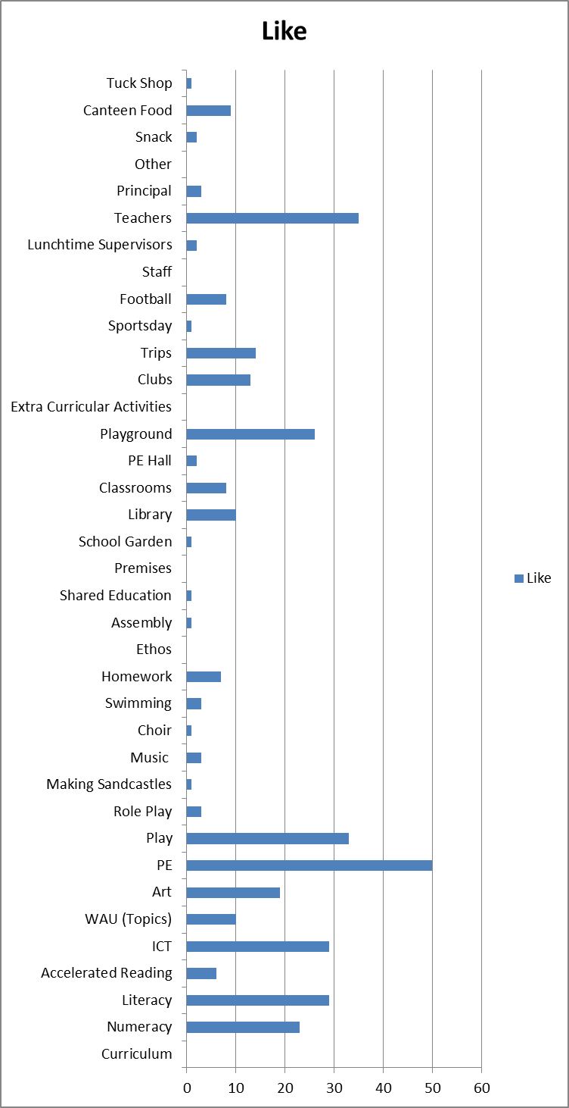

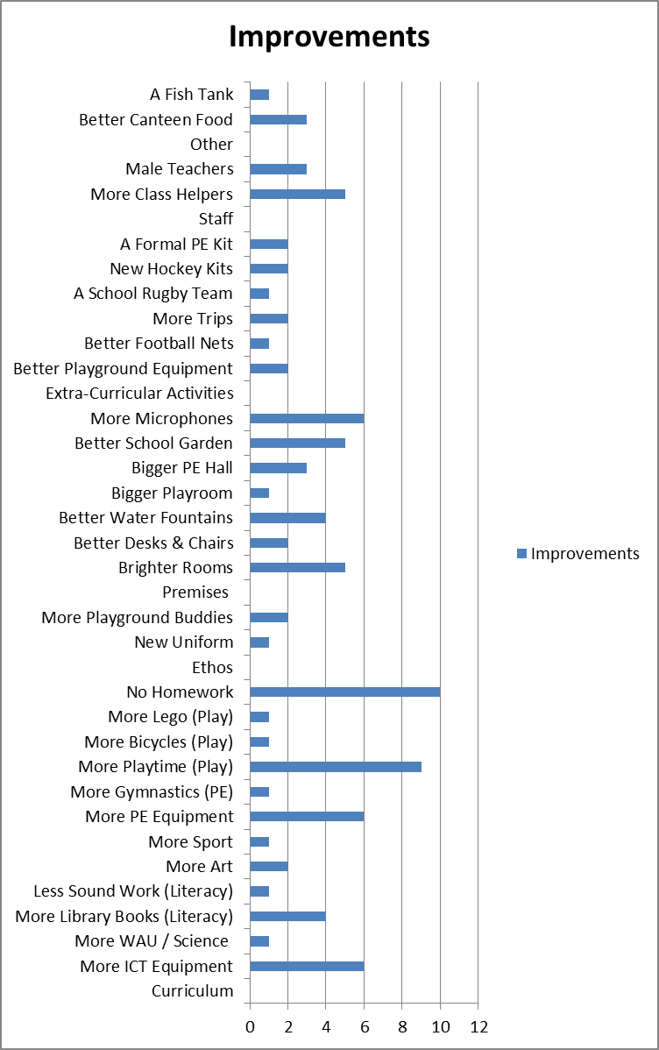
And finally we asked the pupils to list the things that they would improve about the school…

Results of the Pupil Survey 2017
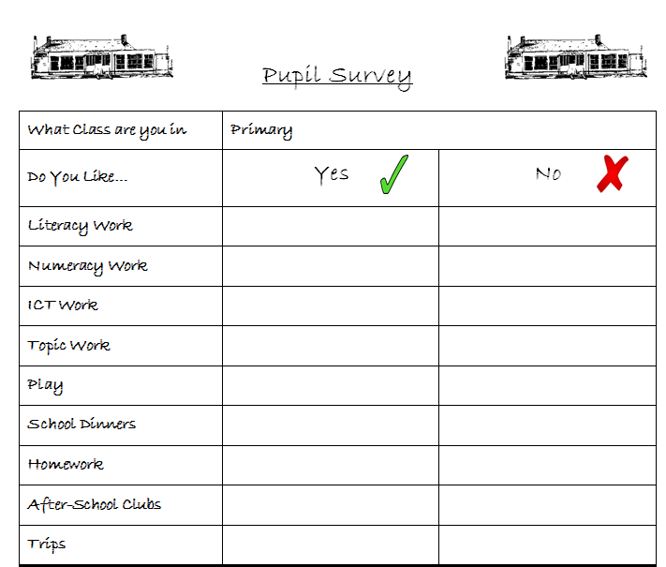
The first section outlined the pupils’ responses to specified questions or statements. The pupils were asked to tick whether they liked or disliked certain things within the school, using the following form…

Whilst some of the responses were a bit of a surprise, such as 25% of the pupils disliking the canteen as a room, other responses were less surprising, such as less than half the pupils liking homework.
Although, it is clear that the 25% of pupils not liking the canteen, corresponds exactly with the 25% of pupils who do not like school dinners.
Another interesting finding is that only just over 60% of the pupils said they liked Literacy Work when asked specifically about it. On the face-of-it, this doesn’t compare very favourably with the other core areas of Numeracy and ICT. However, this was pretty much contradicted when the children were asked in open ended questions what they liked about the school and they responded saying they liked Literacy as much as ICT and more than Numeracy. The reason for this inconsistency will need to be further investigated.

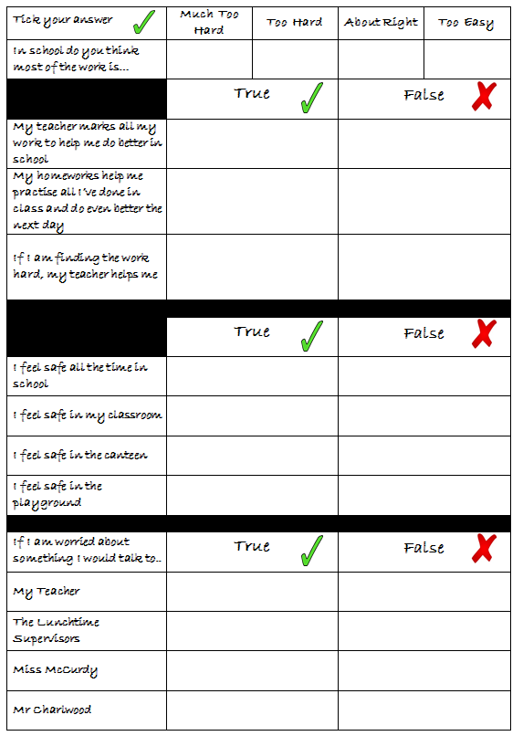
The second section looked mainly at the pupils’ perception of the Learning and Teaching in the school and Child Protection Issues, by asking them a series of questions to which they had to answer ‘true’ or ‘false’
It was very pleasing to see that the pupils responded very positively to the questions regarding the teachers’ active and positive marking and feel that the teachers help them when the work is hard.
It is also pleasing to see that the pupils feel they can speak to their teacher and to the Principal if they are worried about anything. The findings also seem to suggest that Miss McCurdy is less likely to be approached…but then, as the survey was ‘whole-school’ and Miss McCurdy is not so well known to the junior pupils, this was hardly surprising.
It did make me smile though, that quite a few Primary Six pupils responded that they would talk to their ‘Class Teacher’ if they were worried about something, but NOT to Miss McCurdy…even though they are one-and-the-same person !
Of more concern are the findings regarding the pupils’ feeling of safety within the school. Whilst again it was interesting that a substantial number of pupils said they felt safe ‘all the time in school’ … but then went on to say that they didn’t feel safe in the canteen or playground. I asked Mrs Barclay to investigate this issue with the School Council, and the main outcome was that there was more chance of falling in the canteen or getting hurt playing football in the playground, rather than anything more sinister.
Similarly, we would hope that pupils with concerns would feel comfortable talking to any members of the Child Protection team…Teachers, Principal, Vice Principal AND Lunchtime Supervisors...this is another area which needs to be considered, as only around 75% of pupils felt they would be comfortable talking to their helpers at lunchtime.
The pupils did respond very favourably to the questions regarding the School and ECO Councils, and it is pleasing that they see value in their voice being heard in these forums.
The next section looked at the perceived standard of the work in the school. Again this was very interesting with well over half of the pupils responding that the level of work was ‘About Right’.
The break-down of this does not really become clear from the graph…as the vast majority of pupils who felt the work was ‘Too Easy’ came from the Primary One Class…whilst the pupils who felt the work was ‘Too Hard’ generally came from the Primary 6 and 7 classes.

The fourth section of the survey asked the pupils to note areas of school life that they liked, without prompts.
It was very pleasing to see that the top seven answers, whilst maybe slightly contradictory to previous answers were mainly regarding the teachers and curriculum subjects. They were…
- PE
- The Teachers
- The Curriculum area of Play
- The Playground
- ICT
- Literacy
- Numeracy

The Final section of the survey was aimed at asking the pupils, again without prompts, to suggest areas of school life that they felt needed improved. The top ten suggested areas were…
- No Homework
- More Curriculum Play
- More Microphones ?
- More PE Equipment
- More ICT Equipment
- More Class Helpers
- A Better School Garden
- Brighter Rooms
- Better Water Fountains &
- More Library Books
Many of these are already priorities for the school….
- Library Books and Accelerated Reading Books have been a focus of the school for the last few years, with the PTA donating £4,000 this year alone towards improving our stock of books. However, I agree that on-going investment is required
- PE Equipment was also highlighted by the School Council and investment is being made in this area too.
- Brighter rooms are something that I identified when I came to the school 14 years ago. I’ve already painted every classroom in the school and am nearly finished painting the corridors as well. However it is a bit like the Forth Bridge…and once finished, I guess I am getting prompted by the children that it’s time to start again !
- A Better School Garden. Mrs McVicker is already in the process of applying for a Lottery Grant to revamp the school garden, so this is in hand.
- Digital microphones and ICT Equipment are also a focus for the school. We have already made significant investments in Interactive Whiteboards and iPads. But once again, I agree that on-going investment is required and will continue where possible.
- Class helpers are very important, and we very much value the contribution to the school of Evelyn, Donna, Elizabeth, Philomena and Sharon as well as our parent helpers. I would certainly welcome any opportunity to increase the help we have in the classrooms, where possible.
- Play is a major feature of our pre-school and foundation classes and we already maximise the ‘Play’ opportunities in these classes. The PTA have very recently supported this with an investment of £600 for consumables in our Playrooms.
- Better Water Fountains are really under the remit of the Education Authority, so I have passed on the pupils’ request to the Maintenance Department.
- Homework. This is clearly an unpopular issue with pupils, but we see homework as a valuable part of education. However, it will be discussed as a staff to see if it can be streamlined in any way.
Conclusion
The school has found this exercise very beneficial to hear the pupils’ voice and to openly publish and discuss the findings.
I am satisfied that most of the pupils’ wishes are already in hand.
However, we know that there is always room for improvement in any school.

Priorities for change…
- Child Protection is always top priority. Before children can learn, they have to BE safe and FEEL safe. Work needs to be carried out to ensure that pupils feel that they can approach ALL members of the team who protect them, and ensure that the pupils feel as confident in bringing worries to the Lunchtime Supervisors as they do to the Teachers and Principal.
- Homework and any potential changes to our policy and practice will be addressed as a staff. This will also be included as part of our parent survey, to glean your views.
- As a staff we will also discuss how we can ensure a consistent level of pupil satisfaction with areas such as Literacy as they are being developed. The children clearly enjoy the success that they are having through the Accelerated Reading programme…but for some reason this is not being translated consistently into an enjoyment of Literacy as a whole.
- Communication of developments with pupils also needs to be addressed. I stated and demonstrated earlier that most of the areas that the pupils want improved, are also our targets…but the children don’t seem to recognise that they are already being addressed. Maybe, the children are simply wanting the improvements to be completed now…rather than seeing the on-going nature of many of these issues. Nevertheless, I am sure that we could communicate this better, and that will be discussed as a staff and with Governors.

